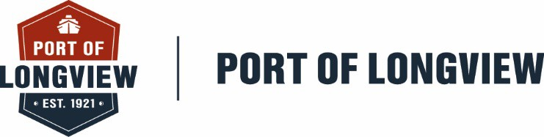

FOR IMMEDIATE RELEASE Date: January 22, 2026
Contact: Jill Page
(360) 425-3305

NOTICE OF CANCELLATION OF PUBLIC MEETING

NOTICE IS HEREBY GIVEN that the Regular Commission Meeting scheduled for 9:00 AM on Wednesday, January 28, 2026, is hereby CANCELLED.

The next Regular Commission Meeting is currently scheduled for 9:00 AM on Wednesday,
February 11, 2026.

Ken Anderton
Chief Executive Officer

